SUPREME COURT JESTERS
Gospel juggling and illusions.

Time: 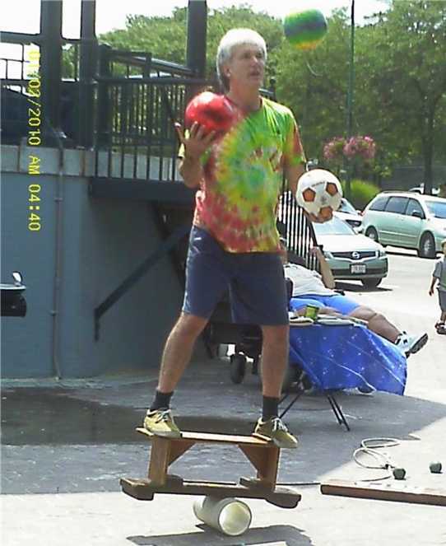
Date:
Location:

