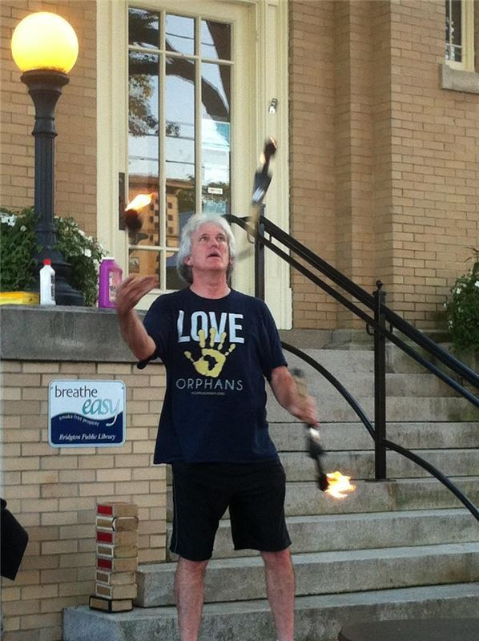
Juggling fire in western Maine.

Contact Richard and Susan Hagerstrom at:
3 Snowy Acres, Bridgton, ME 04009
(207) 632-5307
rhjugglesh@yahoo.com
Supremecourtjesters.org

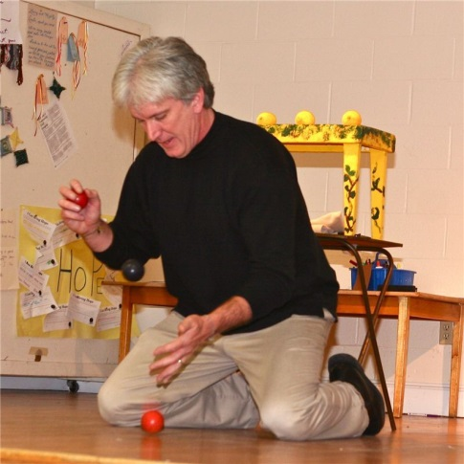
Having performed in venues such as:
> jail and prison chapels around New England
>store front missions in Kentucky
>summer camps in Canada
> a community living in the Quito Ecuador dump
>an orphanage in Juarez, Mexico
> pastors’ conferences in South Carolina
> the Crow reservation in Montana
> the streets of Santo Domingo, DR
> Children's Day celebrations in Asuncion, Paraguay
> Jungle villages in Uganda
the Jesters continue to bring their creative Gospel program everywhere the Lord leads.

Supreme Court Jesters

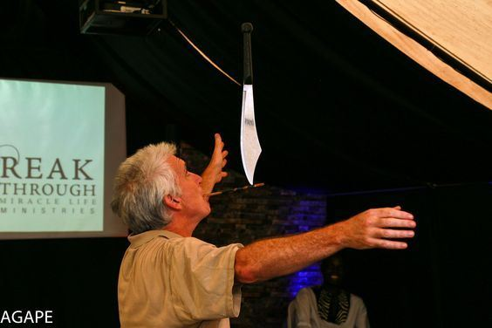
Balancing a machete on a mouth stick in a church in Kampala, Uganda.

JUGGLING
ILLUSIONS
THE GOSPEL

"Thank you for coming and sharing at our church and for encouraging us all in our walk with the Lord as individuals and as families. We have always been a mission’s oriented church and it does our hearts good to hear all that you are doing for the Kingdom’s sake."
-Pastor of Grace Christian Fellowship, Gorham, ME

"These tidings are a long overdue thank you for time and talent employed to entertain and enrich our neighbors. They love how magic brings them a sense of awe and wonder, and we are grateful you gave those gifts to our friends."
-inner city missionaries

"On behalf of all the women who attended yesterday's program, thank you. Our time with you was both refreshing and supportive of faith. your closing remarks on God's grace were especially moving. Some were even crying. As you know, this is a population that feels pretty beat up and / or abandoned. Your coming (to the prison) countered these messages."
-Chaplain, Maine State Prison

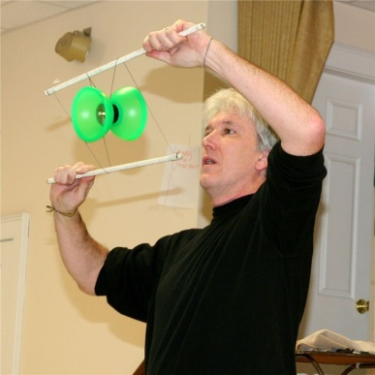

"It was wonderful to have you this past Saturday morning... I am more and more impressed with your message. Your juggling and the work you do with illusions has always been awesome, but I am also more and more impressed with your preaching ability." -Youth Corrections Chaplain
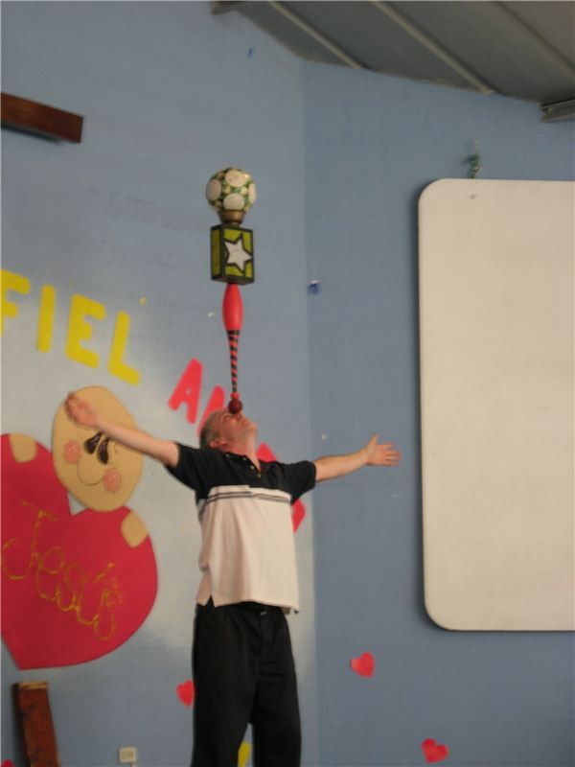
"What a wonderful ministry to both children and adults. In past years it has been a struggle to arrange programing that would hold the attention of all ages, but also challenge each heart with God's gift of Salvation. Thank you for sharing your ministry." -Sunday School Sup't

"You have done a wonderful job, and the Lord has blessed you both with so much, and it's a pleasure to have you share the Lord... Through you, you'll reach out and touch other folks, both older and younger, and maybe open eyes to Christ's love." -M.B.
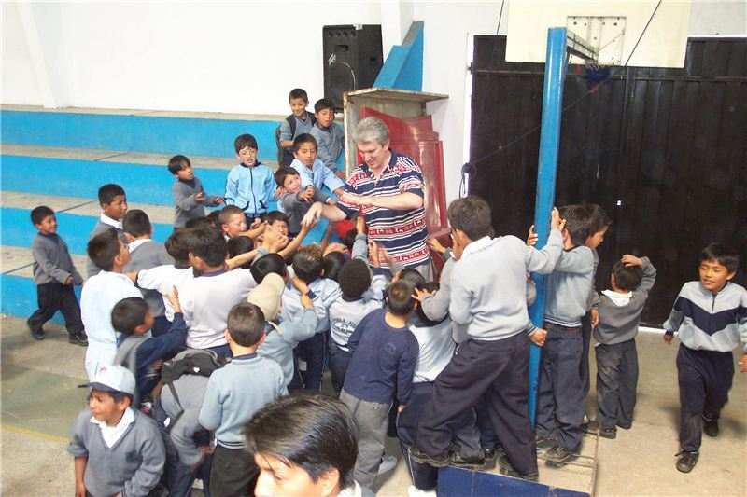
With students in Quito, Ecuador.

"You do a great job reaching people most of us wouldn't take the time to talk with." -P.B.

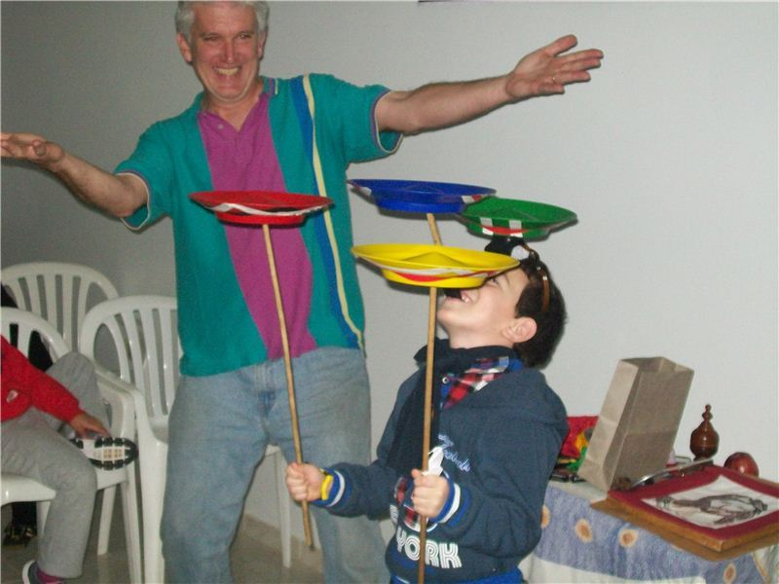
Audience participation in Ciudad Del Este, Paraguay

